Prallethrin

743

743/LV/M/-

Method Extension for Prallethrin UL

Studies for Method Extension of existing CIPAC method for Prallethrin UL.

By
Kevin King
Clarke Mosquito Control
Analytical Laboratory
675 Sidwell Ct, St. Charles IL, 60174
- Introduction
The CIPAC 743/LV/M/- total prallethrin content method was extended to the UL formulation type, that contains prallethrin, with a few modifications. This report was prepared to demonstrate the validity of the extension of the CIPAC 743/LV/M/- for total prallethrin in UL formulations. The analysis was performed by two separate laboratories.
A selective identity test was also performed utilizing GC/MS to confirm the identity of prallethrin in the UL formulation.

- Method Assessment
According to the CIPAC method extension guideline, the method extension of the CIPAC 743/LV/M/- for total prallethrin in UL formulations was investigated.
One UL formulation, CMP123-004, was subjected to this assessment. This assessment was performed by two separate laboratories:
Clarke R&D Laboratory
675 Sidwell Court
St. Charles, Illinois 60174
and
Dow AgroSciences
9330 Zionsville Rd
Indianapolis, Indiana 46268
The nominal content of total prallethrin in the UL formulation tested is 7.5 g/kg
  - Check the availability of a CIPAC method for the formulation concerned (Step 1)
The formulation of interest is a combination active ingredient formulation. There is no existing CIPAC method available for the UL formulation type containing prallethrin. The formulation of interest, CMP123-004, contains prallethrin. The method extension of CIPAC 743/LV/M/- was investigated.
  - Check whether the concentration of the analyte is inside or outside the acceptability range covered by the samples of the original trial (Step 2)
CIPAC 743/LV/M/- was originally evaluated for concentrations of 10.5g/kg (0.9 to 1.1 mg/ml, in final sample solutions) The prallethrin content in the formulation of interest is 7.5 g/kg. This is within the acceptability range of the existing CIPAC method. In the preparation of the sample, the prallethrin concentration in the sample solution was set to 1 mg/ml as described in the sample preparation section of the existing CIPAC method. This is the identical concentration of prallethrin that is present in the calibration solutions, thus the analysis of the sample solution per the CIPAC method falls within the acceptable linearity range.
  - Modification of method has to be changed in order to be specific (Step 4)
In order to apply the CIPAC 743/LV/M/- methodology to the formulation of interest, CMP123-004, the following modifications were applied:
    - Detector temperature and Inlet temperature were changed to 325ºC
    - In this particular formulation a matrix effect was observed. Therefore the method of analysis required quantification to be performed through the methodology of standard addition (utilizing both the external and internal standard solutions) to account for the matrix effects observed.
    - If other UL formulations do not exhibit any matrix effect (suppression or amplification of analyte signal) then the method of quantification can remain as for the existing CIPAC LV method
These changes are considered to be minor modifications.
The Clarke UL formulation of interest, CMP123-004 was observed, through multiple analyses, to exhibit a matrix effect that results in a suppression of the prallethrin response. This suppression effect was confirmed when analyzing the formulation with an internal HPLC method which provided acceptable recovery results. The matrix effect was found to provide recovery levels 10 to 15% below expected results.
In order to achieve acceptable and accurate recoveries of prallethrin in the formulation, it was necessary to account for this matrix effect through the utilization of analysis and quantification using a method of standard addition.
Standard addition is a common and widely used analytical technique to account for matrix effects observed through sample analysis by spiking sample preparations of the UL formulation with varying volumes of a stock standard to generate a known range of standard concentrations in each of the sample solutions, which also contain the unknown amount from the formulation.
In order to adapt the method of standard addition to the CIPAC method, the following procedures were followed:
- A stock standard preparation was required. This was made by weighing, to the nearest 0.1mg, 125mg of Prallethrin analytical reference standard into a 25mL volumetric flask and diluting with acetone to volume.
- The ISTD Stock Solution preparation remained the same as the original CIPAC method. 2g of triphenyl phosphate was dissolved in a 100mL in acetone, and then diluted to volume with acetone.
- Three working standard solutions were prepared as follows:

Standard | Volume of Formulation(mL) | Volume of ISTD Stock Solution (mL) | Volume of Stock Standard Solution(mL) | Volumetric Flask Size(mL)
Std₁ | 3.0 | 1.0 | 1.0 | 20
Std₂ | 3.0 | 1.0 | 3.0 | 20
Std₃ | 3.0 | 1.0 | 5.0 | 20
Each of the respective components was added into a common 20mL volumetric flask, for each standard, and diluted to volume with acetone.
- Samples were prepared by adding 3.0mL of formulation and 1.0mL of ISTD Stock Solution into a common 20mL volumetric flask, then diluting to volume with acetone.
- Linearity was determined by plotting the sample solution as well as all three standard solutions on the same graph with the following parameters:
X-Axis: Volume of Stock Standard solution added (0, 1, 3, and 5 respectively)
Y-Axis: Response factor (taken as a ratio of Prallethrin Response/ISTD Response)
- Quantification was determined using the slope and y-intercept of the linear plot using the following equation:
C_{x} = (b * C_{s}) / (m * V_{x})
Prallethrin Content (g/kg) = C_{x} / 1.14 g/mL
Where:
C_{x} = Concentration of Prallethrin in sample solution (mg/mL)
b = Y-intercept from linearity plot
C_{s} = Concentration of Stock Standard (mg/mL)
m = Slope from linearity plot
V_{x} = Volume of Formulation used (mL)
1.14 g/mL = Density of formulation

  - Validation Study (Step 5)
Linearity, specificity, and precision tests were conducted.
    - Linearity
Linearity was determined by plotting the ratio of Prallethrin Response/ISTD Response on the Y-Axis and the volume of stock standard solution added to the sample and the three standards on the X-Axis. The correlation coefficient (R²) for this curve was ≥ 0.99 thus the instrument is able to prove linearity of prallethrin analysis.

    - Specificity
The sample solutions and a blank solution were prepared identically. A comparative (refer to chromatogram figures) evaluation of the sample solution, blank solution, and the standard solution show that there is no interference with the analysis of prallethrin.

    - Precision (repeatability, r)
The UL sample was prepared in 5 replicates (5 separate sub samples) and analyzed according to the specified chromatographic conditions with the exception of the modifications listed above in 3(C). Per the Horwitz equation, the acceptable %RSD for a sample with a nominal 0.75% concentration is as follows:
%RSD = 2^{(1-0.5*log(C))}
C = concentration of analyte expressed as a decimal
For a 0.75% concentration, this equates to (2 ^{(1-0.5*log(0.0075))}) which is 4.18%. As shown in the table below, the repeatability of this method was satisfactory with a %RSD of 1.39% for Lab 1 and 1.73% for Lab 2.
Lab 1 - Replicate | Prallethrin Content (g/kg) | % Recovery
1 | 7.68 | 102.4
2 | 7.58 | 101.0
3 | 7.66 | 102.1
4 | 7.70 | 102.7
5 | 7.87 | 104.9
Average | 7.70 | 102.6
SD | 0.107
%RSD | 1.39
Lab 2 - Replicate | Prallethrin Content (g/kg) | % Recovery
1 | 7.64 | 101.9
2 | 7.47 | 99.6
3 | 7.47 | 99.5
4 | 7.31 | 97.5
5 | 7.35 | 97.9
Average | 7.45 | 99.3
SD | 0.129
%RSD | 1.73

When combining all results, the overall %RSD between all analyses was 2.28%. When applying the Horwitz Ratio (%RSD of the results / Predicted %RSD from the HorWitz equation) we get a ratio of 0.5 which is considered fully acceptable.
Overall %RSD | 2.28
%RSD per Horwitz Equation | 4.18
HorRat | 0.5
- Prallethrin Formulation Extension method of CIPAC 743/LV/M/-

Outline of CIPAC Method: Total Prallethrin is determined by capillary gas chromatography using flame ionization detection and triphenyl phosphate as internal standard.

Reagents
Acetone
Prallethrin working standard technical product of certified purity. Store refrigerated.
Triphenyl Phosphate internal standard. Must not show a peak with the same retention time as prallethrin.
Internal standard solution. Dissolve triphenyl phosphate (2.0 g) in acetone (100mL). Ensure that a sufficient quantity of this solution is prepared for all samples and calibration standards to be analysed.
Calibration Solution. Prepare calibration solutions in duplicate. Weigh (to the nearest 0.1mg) 90 to 100 mg (s mg) of prallethrin working standard into a volumetric flask (100mL). Add by pipette internal standard solution (5.0 mL) and dissolve. Make up to volume with acetone and mix well (solutions C_{A} and C_{B}).

Apparatus
Gas chromatograph equipped with a split/splitless injection and a flame ionization detector.
Capillary column fused silica, 30 m x 0.25 (i.d.) mm, film thickness: 0.25 µm, coated with crosslinked 14% cyanopropylphenyl 86% dimethyl polysiloxane (DB-1701 or equivalent)
Electronic integrator or data system

Procedure
  - Chromatographic Conditions
Parameter | Specification
Column | fused silica, 30 m x 0.25 (i.d.) mm, film thickness: 0.25 µm, coated with crosslinked 14% cyanopropylphenyl 86% dimethyl polysiloxane (DB-1701 or equivalent)
Injector | Split injection
Split Flow | Approximately 100 mL/min
Injection Volume | 1 µL
Detector | Flame ionization
Column Oven | 245 ºC
Injection Port | 270 ºC
Detector | 270 ºC
Carrier Gas | Helium, 35cm/s
Retention Times | Prallethrin: about 4.7 min  Triphenyl Phosphate: about 10.2 min

  - Linearity Check
Check the linearity of the detector response by injecting 1 µL of solutions with prallethrin concentrations 0.5, 1, and 2 times that of the calibration solution before conducting analysis. The solutions prepared had theoretical concentrations (mg/mL): 0.516, 1.052, and 2.141. When plotted vs their response time the R² value was ≥0.99.
  - System equilibration
Prepare two calibration solutions. Inject 1 µL portions of the first one until the response factors obtained for two consecutive injections differ by less than 1.0%. Then inject a 1 µL portion of the second solution. The response factor for this solution should not deviate by more than 1.0% from that for the first calibration solution, otherwise prepare new calibration solutions.
  - Preparation of sample solution
Prepare sample solutions in duplicate for each sample. Add by pipette 3.0mL of prallethrin technical into a volumetric flask (20 mL). Add by pipette internal standard solution (1.0 mL) and dissolve. Make up to volume with acetone and mix well. (Solutions S_{A} and S_{B}).
  - Determination
Inject in duplicate 1 µL portions of each sample solution bracketing them by injections of the calibration solutions as follows: calibration solution C_{A}, sample solution S_{A}, sample solution S_{B}, calibration solution C_{B}, sample solution S_{B}, sample solution S_{B}, calibration solution C_{A}, and so on. Measure the relevant peak areas.

  - Calculation
Calculate the concentration by using the linear plot of Response Factor (Prallethrin Response/ISTD response) vs Volume of Standard Added utilizing the slope and Y-intercept of the linear regression plot.
C_{x} = (b * C_{s}) / (m * V_{x})
Prallethrin Content (g/kg) = C_{x} / 1.14 g/mL
Where:
C_{x} = Concentration of Prallethrin in sample solution (mg/mL)
b = Y-intercept from linearity plot
C_{s} = Concentration of Stock Standard (mg/mL)
m = Slope from linearity plot
V_{x} = Volume of Formulation used (mL)
1.14 g/mL = Density of formulation
- Prallethrin Identity
To verify and confirm the identity of Prallethrin, GC/MS was used. The following instrument parameters were utilized in the GC/MS analysis:
Oven Program | 50ºC for 2 minutes  10ºC/min to 250ºC for 5 min  10ºC/min to 325ºC for 10min
Run time | 44.5min
Inlet Temperature | 325ºC
Injection Volume | 1µL
Split Injection – Split flow | 100mL/min
Flow velocity | Helium at 45cm/s
Column | Agilent HP-5ms: 30m x 250µm x 0.25µm
MSD Transfer Line | 335ºC
MS Source | 230ºC
MS Quad | 150ºC
Solvent Delay | 5min
Using these parameters, a standard solution of prallethrin was prepared at 1mg/mL as well as a sample solution containing 1mg/mL prallethrin using acetone as the diluent. A blank formulation was also analyzed using the same sample weight as was used to make the sample solution containing prallethrin.
Prallethrin was identified in the standard solution with a clear peak which matched the NIST library search for prallethrin, containing the major ion fragment of 123 AMU.
The prallethrin peak identified in the sample solution was clearly visible and resolved from all other peaks in the sample solution, as well as missing from the blank formulation. The prallethrin peak in the sample solution also matched the NIST library search for prallethrin and had a major ion fragment of 123 AMU.
This analysis supports the identification of Prallethrin in the Clarke UL formulation

- Conclusion
In order to apply the CIPAC 743/LV/M/- to UL formulations containing prallethrin, the method required a change in inlet and detection temperature. In addition, it is important to check whether there are matrix effects affecting the response of the prallethrin analyte. Where there is evidence of matrix effects, then the method of standard addition can be used as the procedure for quantification. This analytical technique is a recognized procedure for dealing with matrix effects and is considered to be a minor modification.
The data shown demonstrates that the method is linear, specific, and has acceptable precision (repeatability, r). The identification of prallethrin in the formulation using GC/MS was also confirmed. Therefore, the modified method is considered appropriate for the determination of total prallethrin in a UL formulation and the extension of CIPAC 743/LV/M/- to UL formulations is proposed by Clarke.

Figure 1. Diluent Injection – GC Analysis
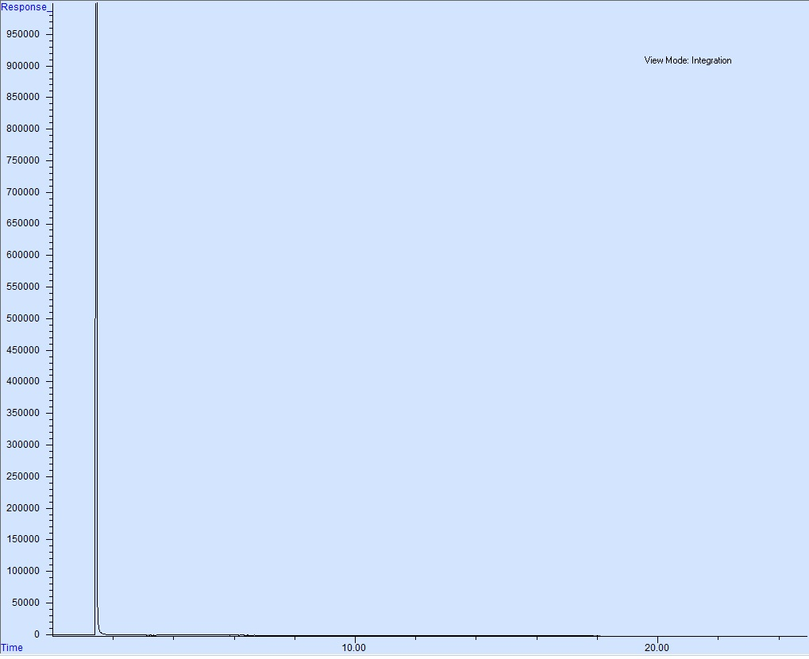
Figure 2. Calibration Solution Injection – GC Analysis
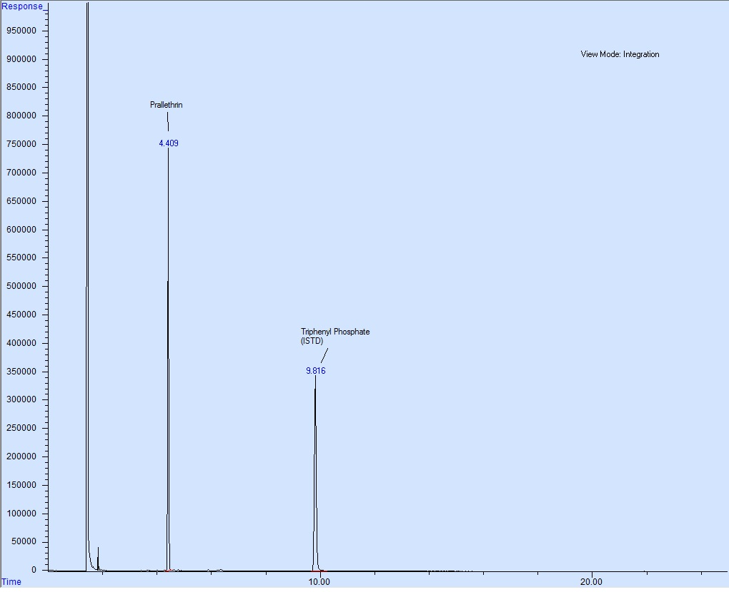

Figure 3. Blank Injection – GC Analysis
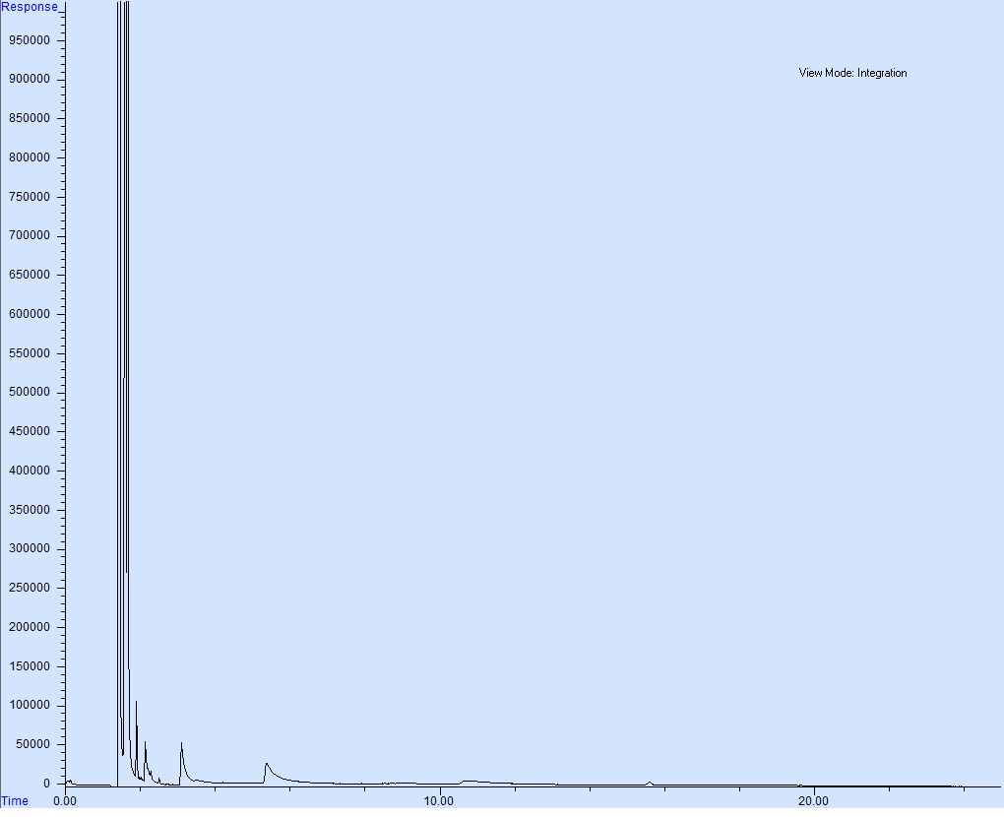

Figure 4. Standard Addition Standard 1 Injection – GC Analysis
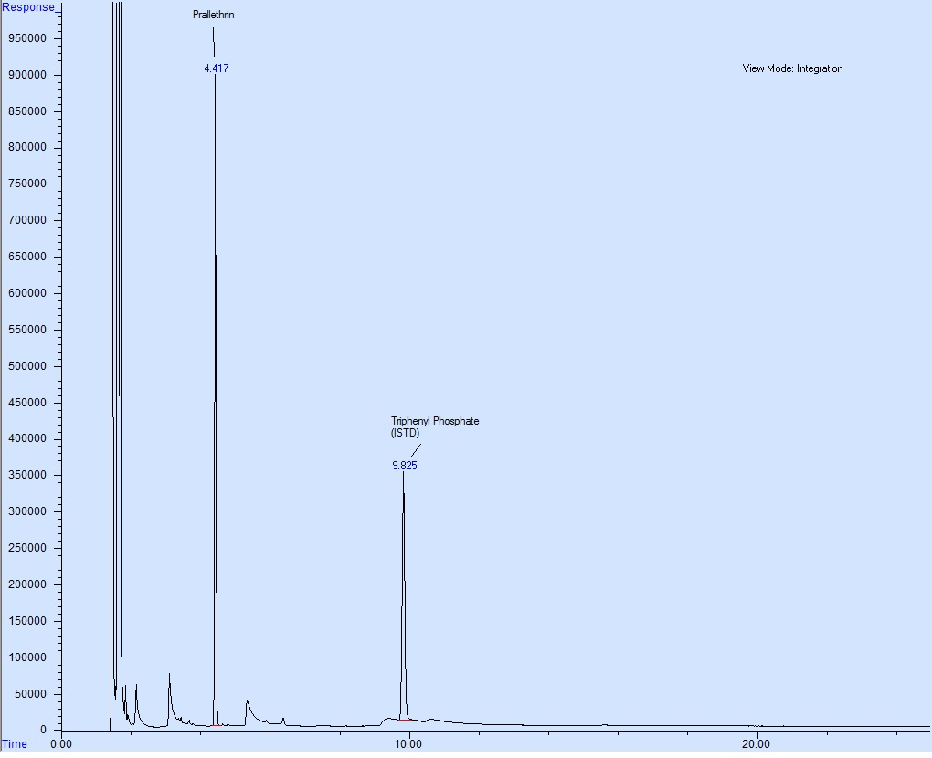

Figure 5. Sample Injection – GC Analysis
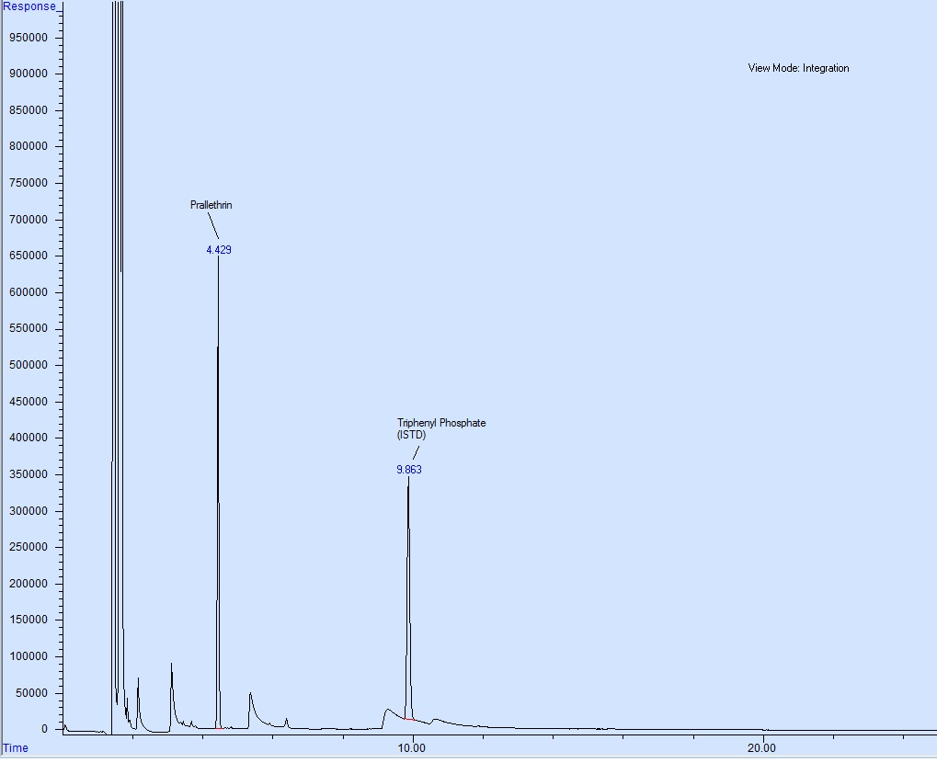

Figure 6. Blank Formulation Injection – GC/MS – Identity Test
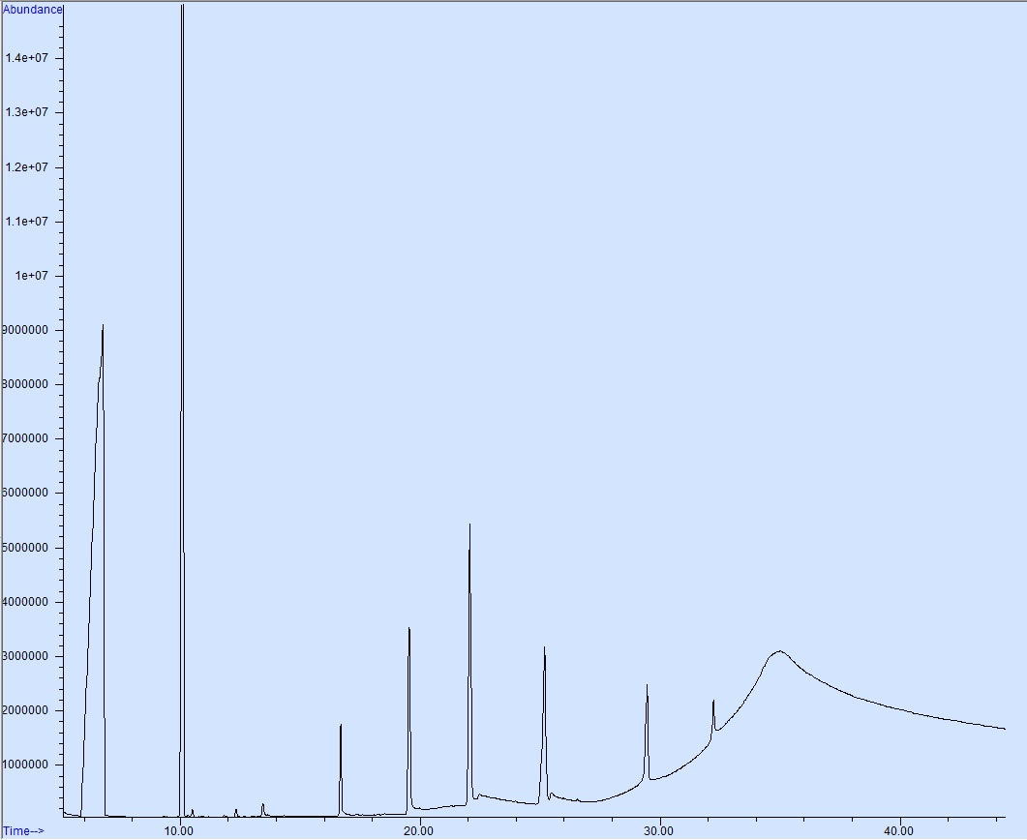
Figure 7. Prallethrin Standard Solution Injection – GC/MS – Identity Test
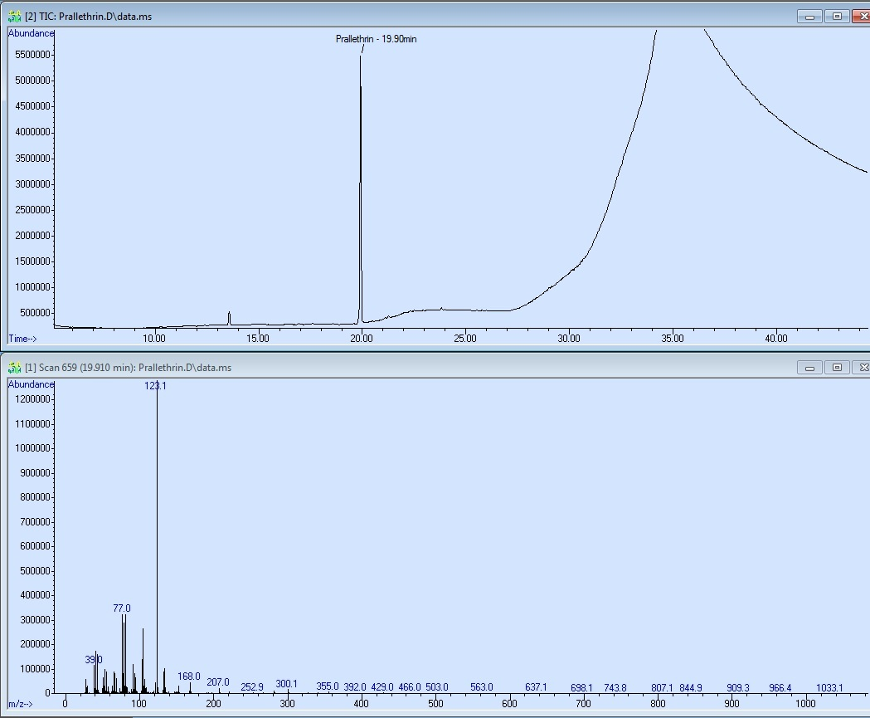
Figure 8. Prallethrin Formulation Solution Injection – GC/MS – Identity Test
